IT
UNIT 39

What time is it? It´s half past ten It´s late It´s time to go home
What day is it? It´s Thursday It´s 16 March It was my birthday yesterday
It´s three kilometers from our house to the city centre
How far is it from New York to Los Angeles
It´s long way from here to the station
We can walk home. It isn´t far

We use far in questions (is it far?) and negatives (it isn´t far). In positive sentences, we use a long way (it´s a long way).

It´s raining It isn´t raining Is it snowing?
It rains a lot here It didn´t rain yesterday Does it snow very often?
It´s warm / hot / cold / fine / cloudy / windy / sunny / foggy / dark / etc. It´s nice day today

Compare It and There:
It rains a lot in winter It was very windy
There is a lot of rain in winter There was a strong wind yesterday

It´s nice to …. etc.
It´s easy / difficult / impossible / dangerous / safe / expensive / interesting / nice / wonderful / terrible / etc. to …
It´s nice to see you again It´s impossible to understand bet It´s wasn´t easy to find your house

Don´t forget it:
It´s raining again (not Is raining again)
Is it true that you´re going away? (not Is true that …. )

EXERCISES

Write about the weather in the pictures. Use It´s …..

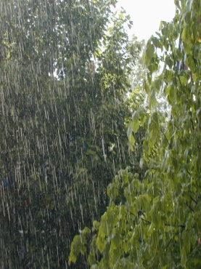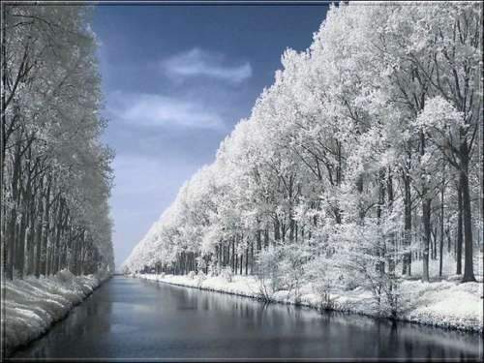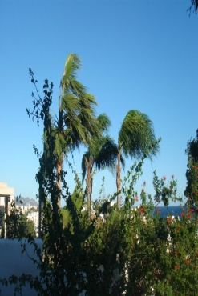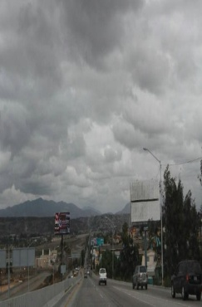

1.- It´s _____________ 2.- _____________ 3.- _____________ 4.- _____________ 5.- _____________ 6.- ____________

Write it is (it´s) or is it.

- What time _________ ?
- We must go now. _________________ very late
- _________________ true that Bill can fly a helicopter?
- What day_________________ today? Tuesday? No, _________________ Wednesday !
- _________________ ten kilometers from the airport to the city center
- _________________ possible to phone you at your office?
- Do you want to walk to the hotel? I don´t know. How far _________________?
- _________________ Lisa´s birthday today. She´s 27
- I don´t believe it? _________________ impossible

Write questions with How far ….. ?
- (here / the station) ___________________________________________________
- (the hotel / the beach) ___________________________________________________
- (New York / Washington) ___________________________________________________
- (your house / the airport) ___________________________________________________

Write It or There

- The weather isn´t so nice today. __________ cloudy
- ____________ was a strong wind yesterday
- ____________ hot in this room. Open de window
- ____________ was a nice day yesterday. ____________ was warm and sunny
- ____________ was a storm last night. Did you hear it?
- I was afraid because ____________ was very dark
- ____________ often cold here, but ____________ isn´t much rain
- ____________ a long way from here to the nearest shop

Complete the sentences. Choose from the boxes

It´s to

- If you go to bed late, _________________________________________ in the morning
- Hello, Jane. ___________________________________________. How are you?
- _________________________________________________. There is too much noise.
- Everybody is very nice at work. __________________________________________________
- I like travelling. _______________________________________________________
- Some cities are not safe. _______________________________________________ at night.

